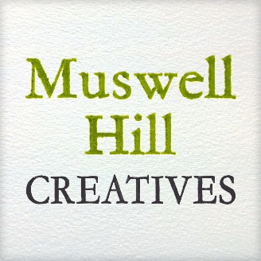
2017 Guest Stall Holders Application Form
Spring Market – Saturday 6th May 2017 – 10.30am-4.30pm
Cost: £85 for 6ft x 29.5 ft (1.8m x 75cm table) under gazebo
DEADLINE – FRIDAY 24TH MARCH 2017
Please use BLOCK CAPITALS

Title |  | First Name |  | Surname
Company name
Address
Town |  |  |  | Postcode
Phone number |  |  |  | Mobile number
Email address

Website address
Instagram ID
Twitter ID
Facebook Page
Stall Holder Product Information. Please give a full description of products you plan to sell on your stall.
Stall Holder’s Signature

Please email to info@muswellhillcreatives.com or post to Muswell Hill Creatives, 42 Muswell Avenue, London, N10 2EL, the following:
- Application form
- Signed copy of the Terms & Conditions
- 5 photographs of your stall/products
- Copy of Public Liability Insurance Cover

General Terms and Conditions

- Stall fee must be paid in advance.

- In the event of inclement weather the Market will still go ahead.

- Muswell Hill Creatives (MHC) reserves the right to reject any application at its sole discretion.

- You are required to accept the stall location that you are allocated by MHC.

- MHC reserves the right to reject any application if too many stallholders apply to sell products of a similar nature

- Each stallholder is responsible for bringing suitable table coverings, props, branding and chair.

- Every effort should be made to ensure that stalls are attractive and inviting to the public

- Stallholders may only sell goods described on their application

- Muswell Hill Creatives will publicise the market and stallholders on its website, social media and via newsletters. All stallholders are asked to actively publicise the event on their own website, social media/newsletter accounts.

Stall Set up/Set Down

- Stalls must be set up and be ready for trading no later than 10.30am on Saturday 6th May. Stalls must be manned at all times during the day until 4.30pm. Assistance with setting up of the gazebos may be required.

- Stall holders are responsible for unloading and loading their stock. Advice on parking and access will be provided nearer the time.

Other

- No power supply is provided

- All stallholders must have Public Liability Cover

- Muswell Hill Creatives shall not be responsible for any loss or damages to merchandise or personal property, nor any injury to any person caused by the activities of the Market, the weather or any other reason or cause. Money and valuables should be kept out of sight and secured.

- Stallholders must keep their stalls and surrounding areas clean and tidy, putting all rubbish in nearby rubbish bins.

I/we agree to the terms and conditions listed.

Signature
Print name
Name of company
Date

